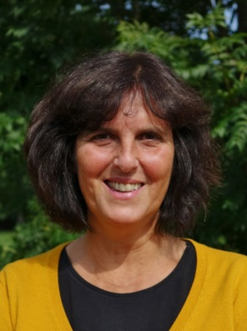
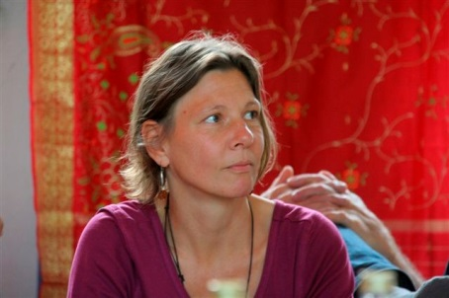
Practical Experiences community using tools of creative communication 20.-22.March
Through tried and tested possibilities such as the Forum, processes of community building and the space of listening, we will explore ourselves and practice listening deeply, express and sharing experiences in the widest sense. We seek answers to questions, such as: Who am I? What does another mean? How is a We-Field built?
The group and its context serve as a field for trying out in an environment of radical subjectivity. This make genuine community and connection a really, without expectations and judgments. For the exercise to reach its full potential, the only requirement of each of us is a mixture of a growing sense of self-awareness, responsibility and empathy. A growing sense of self-awareness for things in the depths of us, which are trying to emerge. Responsibility for showing and integrating the feeling, inside of us. Empathy is needed for accepting all feelings, declined feelings and resistance emerging within ourselves and one and another.
Facilitated by Judith Goldblat (fellow founder of the community “Schloss Tempelhof” www.schloss-tempelhof.de , experienced leader of Forum and CB (after Scott Peck), Therapist of action-analysis) and Ina Welpmann (member of Zegg www.zegg.de, leader of Forum and CB)
Registration: ambre@auroville.org.in

